Coronavirus/Covid-19 Risk Assessment for Bowlers Community Nursery
Effective from 27th July 2020 (with changes regarding clinically extremely vulnerable persons not effective until 1 August 2020).

Setting name: | Bowlers Community Nursery
Name(s) of person(s) covered by this assessment: | - Early years staff  - Children  - Parents  - Catering staff  - Finance Officer  - Cleaners  - Visitors  - Contractors  - Multi Agency Professionals
Tasks and activities covered by this risk assessment: | - General education/childcare provision during COVID-19 pandemic  - General site occupancy and site movement  - Personal hygiene  - Cleaning and sanitisation  - Interactions with maintenance contractors, not including the actual maintenance and compliance activities
Equipment and materials used: | - General educational and play materials (indoor and outdoor)  - Cleaning materials and equipment  - Dining equipment
Name of person completing this risk assessment: | Aoife Morgan | Date of completion: | 15th April 2021
Risk assessment approved by: | Trustees of Bowlers Community Nursery | Date of approval: | 15th April 2021
Date risk assessment to be reviewed by: | 4th August 2020 (every 4 weeks, or when there are changes in information)  18th September 2020  22nd October 2020  17th November 2020  16th December 2020 | Risk assessment no: | 5
Record of risk assessment reviews
Date of review: 31st July 2020 Reviewed by: Aoife Morgan Comments / date of next review: 14/08/2021
Date of review: 18th September 2020 Reviewed by: Aoife Morgan Comments / date of next review: 22/10/2021
Date of review: 23rd October 2020 Reviewed by: Aoife Morgan Comments / date of next review: 18/11/2021
Date of review: 23rd December 2020 Reviewed by: Aoife Morgan Comments / date of next review: 23/01/2021
Date of review: 23rd January 2021 Reviewed by: Aoife Morgan Comments / date of next review: 23/03/2021
Date of review: 15th April 2021 Reviewed by: Aoife Morgan Comments / date of next review: 28/05/2021

Background
This risk assessment will consider the risks to children, staff and others impacted by the infection if a person attending the setting (e.g.children, staff, contractors, visitors and household members of children and staff) while the coronavirus, leading to Covid-19 infection, is in circulation in the general community in the UK. It is based on government guidance “. https://www.gov.uk/government/publications/coronavirus-covid-19-early-years-and-childcare-closures/coronavirus-covid-19-early-years-and-childcare-closures ” , which indicates that it cannot be a ‘one-size-fits-all’ approach and setting leaders are best suited to identify the system of controls that will let them effectively minimise the risk while delivering the curriculum.
Note: this risk assessment only addresses hazards directly related to physical exposure to Coronavirus/Covid-19. The setting should separately consider non-physical hazards e.g: stress to staff and hazards not directly related to exposure to the virus, e.g. working at home, catering, including food preparation and building management arrangements.
Hazard - Coronavirus (SARS-CoV2), which is spread in minute water droplets that are expelled from the body through sneezing, coughing, talking and breathing. The virus can be transferred to the hands and from there to surfaces. It can survive on surfaces for a period after transfer (depending on such things as the surface type, its moisture content and temperature).
Risk Consequence - The vast majority of people who become infected with COVID-19 will have mild to moderate symptoms which will self-resolve, and will not require further NHS treatment. While Covid-19 illness can be fatal, this likelihood disproportionately impacts adults and specifically those with pre-existing conditions who should follow the relevant government guidance.
- severity of disease in children – there is high scientific confidence that children of all ages have less severe symptoms than adults if they contract coronavirus (COVID-19)
- the age of children – there is moderately high scientific confidence that younger children are less likely to become unwell if infected with coronavirus (COVID-19)
- severity of disease in adults – a small proportion of adults suffer a very serious or fatal illness, if infected. The likelihood of serious or fatal consequences is much greater for older people and those with underlying health conditions e.g. the clinically vulnerable and extremely clinical vulnerable for whom personal risk assessments should be completed.
Likelihood - is based on the likelihood of transmission, which may lead to one or multiple fatalities.
If personal hygiene, setting cleaning measures, and social distancing measures by adults (in accordance with government guidance) are followed and all very high risk/very vulnerable (previously shielded, until shielding was suspended) persons and high risk/vulnerable persons (see NHS lists) work to a personal risk assessment that identifies how they can optimise their social distancing, likelihood of transmission leading to a fatality will be low for persons who are not clinically vulnerable and medium for clinically extremely vulnerable/clinically vulnerable persons. Where strict social distancing cannot be achieved for clinically extremely vulnerable persons, alternative controls should be considered in their personal risk assessment in addition to these shown in this risk assessment in order to prevent their risk becoming high.
Note: clinically extremely vulnerable adults should continue to shield at home until 31 July 2020. All clinically extremely vulnerable and clinically vulnerable persons who cannot work from home should discuss with their managers how to minimise their risk and this should be recorded in their personal risk assessments. Clinically extremely vulnerable children should also remain at home until 31 July 2020 and should then be supported in following the advice of their specialist health professionals when returning to the setting.

A - Essential general control measures – applicable to all children, staff and others in Bowlers at all times
Procedures in place, including reminders to all adults and children and poster displays to ensure:
- Children and staff stay at home if,
  - unwell with coronavirus (COVID-19) symptoms, or
  - in a household where somebody else is symptomatic, or
  - if instructed to do so by the NHS Test and Trace system or by a Public Health England, Camden and Islington Public Health or other health protection team officer, or
  - where quarantine applies following travel abroad
- Parents/guardians/carers of children, staff and their households understand their obligation for anybody displaying symptoms to be tested if and follow NHS guidance.
- Frequent washing of hands with soap and water for 20 seconds and dry thoroughly using the correct hand washing technique. This includes on arrival at the setting, before and after eating, after breaks, after changing rooms and after sneezing or coughing
- Use a tissue or elbow to cough or sneeze and use bins for tissue waste (‘catch it, bin it, kill it’).
- Not touch their mouth, eyes and nose.
- Follow Bowlers procedures for removing any face coverings used on the way to the setting safely (not touching the front) and either putting them in a plastic bag, if reusable, or disposing in a bin (if disposable), then washing hands (Note – children under 11 are not required to wear face coverings on public transport and in shops and children under 3 should not use face coverings at any time).
- Implement normal personal hygiene and washing of clothes following a day in an educational or childcare setting.
- Follow Bowlers procedures to minimise mixing between groups. Adults should minimise physical contact between individuals and maintain social distancing with other adults.
- Parents and carers to be encouraged to attend Bowlers consistently and minimise the number of different settings a child attends (to minimise the mixing of individuals).

B - Setting Infection Prevention Measures Bowler’s must have processes and facilities in place
- To minimise contact with persons unwell with coronavirus symptoms or who have somebody in their household with symptoms, including
  - Procedures to ensure staff and children in these situations do not attend the setting
  - Procedures to isolate and send home any children or staff who develop symptoms while at the setting
  - Procedures to support children and staff with engaging with NHS Test and Trace.
  - Procedures to contact the local health protection team if anybody who has attended the setting (staff, children, visitor or contractor) has tested positive and then follow Public Health’s advice.
- To enable thorough hand cleansing at appropriate times
  - Well maintained, regularly cleaned, hand washing facilities e.g.running water, soap and either electric dryers or disposable hand towels or (where running water not available) hand sanitiser stations stocked with suitable sanitiser available at appropriate locations.
  - Children and staff educated to cleanse their hands at appropriate times and age appropriate supervision and assistance provided for children where needed.
  - Regular reminders of the required behaviours and staff leading by example.
- Promote good respiratory hygiene by,
  - Ensuring tissues and bins with lids are available.
  - Bins regularly emptied and tissues re-stocked at appropriate intervals.
  - Appropriate education of “catch it, bin it, kill it” approach and support for pupils who need assistance e.g. EYFS and pupils with additional needs.
- Enhanced cleaning – use the methods to be published in Public Health England’s revised guidance on general cleaning in non-healthcare settings.
  - Identify rooms and facilities/areas used by multiple groups e.g.toilets, play areas
  - Identify frequently touched surfaces (e.g. door handles, toilets, wash hand basins) that require enhanced “frequently touched surfaces” cleaning.
  - Schedule frequent and enhanced cleaning for frequently touched areas and areas used by different groups/cohorts, ensuring suitable competent staff and supplies of standard cleaning products and materials are available
  - Where cleaning is not practical (e.g.books), arrangements should be put in place to store items out of reach/out of use, so that they are left unused and untouched for 48 hours for most materials and 72 hours for plastics.
- Minimise contact between groups of individuals where possible
  - Review the arrangements within Bowlers to identify how we can minimise mixing.
    - For example, consider using different rooms/spaces for different age groups if possible and keeping these age groups apart as much as possible while still providing suitable care, learning and development for the children however mixing should still be minimised.
  - Set up staff facilities to enable 2 metre social distancing among adults wherever possible, both in the play areas and non-teaching areas such as offices and welfare facilities/staff rooms.
    - In EYFS, it is acknowledged that social distancing will not be possible with and among the children, so staff should interact with one group (class, age-group, cohort or equivalent), wherever possible and minimise the time they are in very close proximity to children. They should also consider their working practices, so that when close to children they position themselves so that they are not face-to-face (e.g.beside a child). Any specialist staff working across more than one class/group should review their work practices to minimise direct contact with pupils while still delivering an appropriate service.
    - Consider capacity of staff rooms/welfare facilities and consider staggering break and lunch times to no more than 2 staff at any one time.
    - Where staff work across multiple settings, they should also minimise the number of settings, where practical (or, if practical, spend extended blocks of time in each setting, rather than moving between settings on a daily basis if possible).
  - Set up arrangements for children arriving and leaving the setting that prevent the gathering of parents and children at the setting entrance and minimise rush hour use of public transport.
    - Consider the setting’s site and demography to decide how this can be best achieved. Options to consider can include,
- Staggered start and finish times (unless this leads to parents gathering outside the gates with siblings, which is not desirable).
- Using different entrances, so that different groups arrive at different points and do not mix.
- Use of socially distanced outdoor waiting areas.

1 | Children, household members or staff symptomatic | Parents/carers, children, staff, contractors and other visitors informed that nobody who is symptomatic or in a household where somebody else is symptomatic may attend setting or enter the premises - they must all follow the government’s self-isolation, testing and tracing guidelines.  Remind parents/carers/staff/children/visitors etc. e.g. by notices at entrance, that nobody in such a household may attend the setting and that they must be tested and follow the NHS Test and Trace process  See also Ref 12 below for a suspected case of Covid-19 on site. | Medium | Parents/ Carers and Staff will be given regular updates via email in terms of any changes to Government guidance.  Staff and Parents/Carers will also be given a hand out should they develop symptoms and need to be tested. This will inform them of all the steps required.
1.1 | Child or staff member contacted by NHS Test and Trace as a contact | Self-isolate in accordance with NHS Test and Trace instructions (if persons follow these instructions, the likelihood of transmission to others is minimised) | Low | Children and Staff to self-isolate for 10 days in accordance with NHS Test and Trace instructions.

1a | Staff - Clinically extremely vulnerable (previously shielded) and clinically vulnerable staff working at the setting | A personal risk assessment should be completed for each staff member. Where the nature of their job means that they cannot work from home, their risk assessment must address minimising their risk of exposure while undertaking their job role.  Review work methods to optimise social distancing, where practicable.  Observe personal hygiene best practice.  Where the member of staff works with very young children e.g.nursery or reception, consider whether there are options for working with a slightly older age group where social distancing is more practical.  The guidance for extremely clinically vulnerable/shielding persons is available at https://www.gov.uk/government/publications/guidance-on-shielding-and-protecting-extremely-vulnerable-persons-from-covid-19/guidance-on-shielding-and-protecting-extremely-vulnerable-persons-from-covid-19 and for clinically vulnerable persons is https://www.gov.uk/government/publications/staying-alert-and-safe-social-distancing/staying-alert-and-safe-social-distancing#clinically-vulnerable-people | Medium
1b | Children who are clinically extremely vulnerable (previously shielded) or clinically vulnerable | These children can return to Bowlers, in line with the government guidance. They should be assisted to socially distance where applicable.  If a local rate of disease rises, clinically extremely vulnerable children may be advised to temporarily shield again, hence be temporarily absent from the setting.  These children should take advice from their specialist health professional and, where applicable, Bowlers will support the child in following this advice. | Medium | All children who are clinically extremely vulnerable can return to Bowlers from the 3rd August 2020, along with medical advice from their clinician.

1c | Household members of children and staff who are clinically extremely vulnerable (previously shielded) or clinically vulnerable | The staff and children living in households with extremely clinically vulnerable persons should attend the setting as normal.  The children and staff should follow the government about personal hygiene measures and social distancing as far as practical, both at nursery and in the home environment.  Children and staff members will be supported by Bowlers to follow personal hygiene and social distancing best practices.  Families can be referred to the health visiting service, who will individually be able to discuss their concerns and risks. | Low
2 | General activities | Bowlers to review how mixing of individuals in the setting can be minimised (see B5 above).  Where possible, staff should not spend extended periods in very close proximity to the children– see B5c above.  We have now reintroduced some sensory / malleable activities such Water, Cornflour and Playdough and follow DfE and PHE guidance around such activities. 15/03/21  Books, games and other resources can be shared within the group and should be cleaned regularly, where appropriate. Where equipment is shared between cohorts, meticulous cleaning is needed between cohorts. As an alternative, or where cleaning is not practical, items can be left unused for a period – see B4d above reference rotation of items)  Parents to be requested to not allow their children to bring toys, or any other non-essential items to Bowlers.  Arrangements for frequent handwashing, including additional support where needed by children (see B2), good respiratory hygiene (B3) and room cleaning (B4) in place.  Removing ill/symptomatic children / staff (see B1b and ref 12 below). | Medium

3 | Use of toilets/nappy changing facilities | All staff and children instructed and supported to wash hands correctly after using toilet (see B2 above).  Enhanced cleaning of toilet and changing facilities (see B4 above).  Nappy change areas should be wiped down with sanitising solution or wipes after every change. | Medium | Covid-19 cleaning schedules have been devised and placed in the children and adult toilets.

4 | One-on-one teaching and personal care for infants and children with additional needs | The majority of staff in Bowlers will not require PPE beyond what they would normally need for their work. PPE is only needed in a very small number of cases, including:  - where an individual child becomes ill with coronavirus (COVID-19) symptoms while at a setting, and only then if a distance of 2 metres cannot be maintained  - where a child already has routine intimate care needs that involves the use of PPE, in which case the same PPE should continue to be used  - see https://www.gov.uk/government/publications/safe-working-in-education-childcare-and-childrens-social-care/safe-working-in-education-childcare-and-childrens-social-care-settings-including-the-use-of-personal-protective-equipment-ppe  PPE should be worn for nappy changes in line with usual Islington guidance for changing nappies of babies and children with SEND:-  Islington guidance for changing nappies of babies and children with SEND  Masks: Staff can wear the same face mask for the whole of a ‘session of care’ (e.g. when changing several nappies in a row OR feeding several babies in a row OR when keeping the mask on without taking it off during a range of activities). The duration of a single session in a mask will vary. Once the mask has been removed it should be disposed of safely. PPE should not be subject to continued use if damaged, soiled, compromised or uncomfortable. PPE should not be re-used once it has been taken off.  - Aprons and gloves are subject to single use as per Standard Infection Control Precautions, with disposal and hand hygiene after contact with individual children.  Minimise close contact time without negative impact on personal care. Where close contact is necessary strategies to minimise close contact can include sitting or standing behind or beside and above the child, where practicable, rather than face-to-face  Where a pupil is displaying symptoms, they should be removed from the play area and the appropriate procedures followed (see B1b and ref 12 below). | Medium | All staff to ensure that appropriate PPE is worn and disposed of appropriately between nappy changing.

5 | Outdoor activities  Outdoor transmission likelihood believed to be much lower than indoors. | Play equipment should be cleaned regularly.  Hand washing before and after each break and/or use of play equipment.  All staff including (admin staff, finance officer, chef etc) must try to maintain social distancing where possible to safeguard themselves and set an example to the children. | Low | Both the office and the kitchen should be considered independent bubbles where possible.  Only 2 staff at any one time in the Staff Room to support social distancing.  15/04/2021
6 | Movements to other rooms (Baby room) | Interaction between groups should be minimised to as short a period as possible. | Low | Both the baby room and main floor will be considered independent bubbles, however after lunch the children that sleep will enter the baby room. Other than this there will be limited interaction between the two groups where possible.

7 | Lunch and snack | We will continue to operate as we previously have, babies eating in the baby room, all 2 - 3year olds eating with each other and their key adults and all 3 – 4year olds sitting together with the adults that support this group of children.  Children should be supervised to wash their hands before and after eating.  Tables are high touch surfaces and must be cleaned thoroughly after usage.  Bowlers kitchen will operate in line with the government guidance for food businesses on coronavirus/COVID-19 - https://www.gov.uk/government/publications/covid-19-guidance-for-food-businesses/guidance-for-food-businesses-on-coronavirus-covid-19 | Low
8 | Arrival/departure | From the 14th September all Children will arrive through Bowlers main entrance. Parents who have children in the baby room will continue to enter the nursery to drop off and collect their child. From the 5th October all Parents / Carers entering the baby room to drop off or collect their child are now required to wear a facial mask, failure to do so will mean that their child will be brought to the door. Children should be supervised to wash their hands when they arrive.  Parents should only enter rooms if essential or settling-in and must be discouraged from congregating outside the setting entrance / exit. Consider signage. No visitors unless essential to enter the setting.  Prior to entering, any parent must be inducted into the setting’s COVID-secure procedures and must agree to follow them (e.g. social distancing from other persons in the room, hand cleansing before entering and on departure) | Low | From the 4th January no parents will be able to come on site, with the exception of those parents who are settling their children and they will be required to wear a mask. Baby room staff will greet their parents at the main entrance and bring them to the baby room. All parents are now required to wear a mask outside of the nursery premises (main door) 04/01/21

9 | Maintenance and contractor visits | Contractors to be advised of setting’s social distancing and hygiene arrangements on or before arrival. Their telephone number should be recorded with the other visitor/contractor details, in case NHS Test and Trace need to contact them.  Contractors not to mix with any group of children or staff, and their arrival time to be pre-agreed.  Contractors must provide RAMS (Risk Assessment and Method Statement) for all activities on site bearing in mind COVID-19 risk. The setting should induct contractors in their COVID-secure arrangements.  Where possible, visits should happen outside of setting hours. | Low | All Visitors / Contractors are required to complete a Covid-19 Questionnaire upon entry of the building and their temperature taken.  They are also required to wear a mask while on site, unless exempt.  04/01/21
10 | Meetings with staff, parents etc. | Wherever possible, all meetings to be conducted by telephone, video conferencing etc.  Essential other meetings to be conducted with social distancing and hygiene in place.  Where visitors attend site, their telephone number should be recorded with the other visitor details, in case NHS Test and Trace need to contact them. | Low | Bowler’s staff meetings will continue via zoom every other week.  For new children starting the key person will host a zoom meeting the week before the child starts.
11 | First Aid/Ill Health (other than Covid-19 symptoms) | Further guidance issued to first aiders on providing general first aid, CPR and resuscitation – see https://www.resus.org.uk/media/statements/resuscitation-council-uk-statements-on-covid-19-coronavirus-cpr-and-resuscitation/covid-community/ | Medium

12 | Suspected case on site | Establish protocol and train all staff on swift and safe response to suspected cases on site.  Communicate protocol clearly to parents and carers.  Designate a safe area for symptomatic child/children waiting to be collected.  Acquire PPE for staff to use if supervising a child waiting to be collected, train staff on whereabouts and safe use of PPE. Set up PPE stock record/ ordering system.  https://www.gov.uk/government/publications/safe-working-in-education-childcare-and-childrens-social-care/safe-working-in-education-childcare-and-childrens-social-care-settings-including-the-use-of-personal-protective-equipment-ppe  Considerations for protocol:  Reducing COVID-19 risk  - Ensure that parents and carers are aware of COVID-19 symptoms:  - a high temperature – this means you feel hot to touch on your chest or back (you do not need to measure your temperature)  - a new, continuous cough – this means coughing a lot for more than an hour, or 3 or more coughing episodes in 24 hours (if you usually have a cough, it may be worse than usual)  - a loss or change to your sense of smell or taste – this means you've noticed you cannot smell or taste anything, or things smell or taste different to normal  - Ensure that parents and carers are aware they should not send children to the setting if they are unwell with COVID-19 symptoms or if someone living in their household is unwell with COVID-19 symptoms. If the child is unwell they should self-isolate for 10 days & get a test. Household members should also self-isolate for 10 days. If someone in the household is unwell, the child should self-isolate for 10 days.  - Ensure all children are reminded daily to inform their Key Person or an adult if they feel poorly.  COVID-19: guidance for households with possible coronavirus infection  Preparation for possible COVID-19 illness  - Establish clear communication protocol in setting, for quickly notifying key staff and parent/carer  - Set up COVID-19 risk/ incident log, for oversight by the Manager or their delegated safeguarding lead and further debrief/ training.  - Ensure Business Continuity Plans are up to date and consider how to manage/what to do if a large number of staff are required to self-isolate.  Responding to possible COVID-19 illness  - Child/staff member with symptoms should go home as soon as possible and get tested for COVID-19 as soon as possible, and at the latest within the first 5 days of symptoms starting.  - Tests for the general public can be booked online at www.nhs.uk/ask-for-a-coronavirus-test (or by calling 119)  - Tests for essential workers are prioritised and can be booked at: https://www.gov.uk/apply-coronavirus-test-essential-workers  - For help with testing: https://www.nhs.uk/contact-us/get-help-with-asking-for-a-coronavirus-test/  - While waiting for collection, the child should wait in a well-ventilated room with a closed door, or if they cannot be isolated then move them to an area which is at least 2m away from others.  - PPE is required if a child or staff falls ill with coronavirus symptoms (young child or with complex needs) and requires direct personal care on site:  - Fluid resistant surgical mask worn by supervising adult if 2m distance cannot be maintained  - Disposable gloves, disposable apron, fluid-resistant surgical mask worn if contact is necessary  - Eye protection if there is a risk of splashing (e.g. coughing, spitting, vomiting)  - Parents/ carers/ symptomatic staff provided with self-isolation advice, and information about NHS Test and Trace – settings can access further information and resources on NHS Test and Trace https://www.camden.gov.uk/covid-19-advice-and-guidance-working-with-residents#ubos for Camden and https://www.islington.gov.uk/social-care-and-health/support-and-guidance-during-covid-19/useful-guidance-and-resources-covid-19/test-and-trace-for-local-organisations for Islington  - Safe disposal of PPE and areas occupied and equipment used by the affected person cleaned and disinfected, as per guidance  https://www.gov.uk/government/publications/covid-19-decontamination-in-non-healthcare-settings  - Clean the affected area with normal household disinfectant  - Supervising staff member and cohort wash hands thoroughly, do not need to go home unless they develop symptoms or the child subsequently tests positive.  - If the setting needs support with a possible case or has an enquiry contact the local Public Health Team for support – email CIPHAdmin@islington.gov.uk  - Manager to follow up if test result is not received.  - If the test result is:  - Negative: unwell person can return to the setting if they feel well enough and their fellow household members can end their self-isolation.  - Positive: unwell person must complete 10-day self-isolation and log onto NHS Test and Trace to share their recent close contacts. The manager will also need to be forwarded the positive test result which will be placed in the child’s confidential folder.  - The setting should notify PHE London Coronavirus Response Cell (LCRC 0300 303 0450) of all confirmed cases in the setting. Template letters and other communications materials for parents and staff members will be shared by LCRC and the local Public Health Team.  - PHE LCRC will undertake a risk assessment and usually will advise that the class or year group who have been exposed should be sent home and advised to self-isolate for 10 days. The other household members of that wider class or group do not need to self-isolate unless a household member becomes symptomatic.  - As part of the NHS Test and Trace service, if other cases are detected within the cohort or wider setting, PHE LCRC will conduct a rapid investigation and advise settings. Closure of the whole setting will not generally be necessary. | Medium | All staff have completed Infection control and prevention training in May 2020.  A stock record system has been devised to ensure that before stock runs low we place a new order. However at times it can prove very difficult sourcing PPE. At this point I have had to contact Islington (Julia Bleet)  December 2020

13 | Cleaning | Cleaning should be done in line with guidance in https://www.gov.uk/government/publications/guidance-for-full-opening-special-schools-and-other-specialist-settings/guidance-for-full-opening-special-schools-and-other-specialist-settings#section-1-public-health-advice-to-minimise-coronavirus-covid-19-risks  Cleaning to be done while children not in rooms where possible.  PPE for cleaning in line with COSHH/cleaning risk assessment, including of metal/hard surfaces and toilet facilities. Normal cleaning materials (e.g. detergents) to be used except when a case of Covid-19 is suspected – then follow https://www.gov.uk/government/publications/covid-19-decontamination-in-non-healthcare-settings  Instruction provided on how to use PPE correctly including hand hygiene.  Frequently touched surfaces being cleaned more often than normal.  Bins should have lids and foot pedals.  Separate cleaning activities risk assessment must be completed by competent person and communicated to childcare staff and cleaning staff. | Medium

14 | Staff welfare facilities | Consider maximum occupancy of the staff room bearing in mind social distancing guidelines.  Staff to socially distance at all times and clean down all equipment before and after use.  Do not share cups, crockery and cutlery. | Medium | Only 2 members of staff in the staff room at any one time.  Staff have to provide their own cups etc.
15 | Travel to/from setting  a) by foot, bike or private car | All persons (staff and children) to avoid public transport where possible, walking and other forms of travel should be encouraged.  Where walking is not possible for staff, arrangements to be made for them to park on-site, where possible. | Low | All staff that have too far to travel by foot and have a car, provision will be made for them to park on the Crouch Hill Site.
 | b) by public transport | If public transport use is unavoidable, consideration to be given to arrangements to minimise, where practical, rush hour use of public transport by staff and children.  Face coverings to be worn on public transport, in line with government guidance. Setting to put suitable procedures /arrangements in place to support the hygienic removal of face coverings on arrival at setting (see B3d above) | Medium

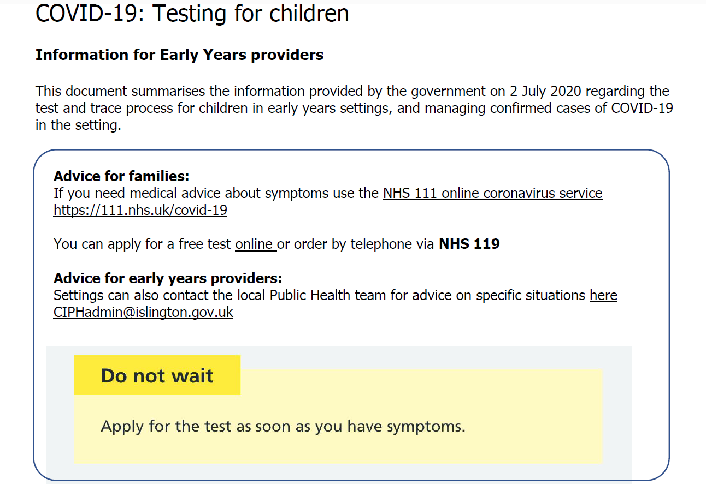
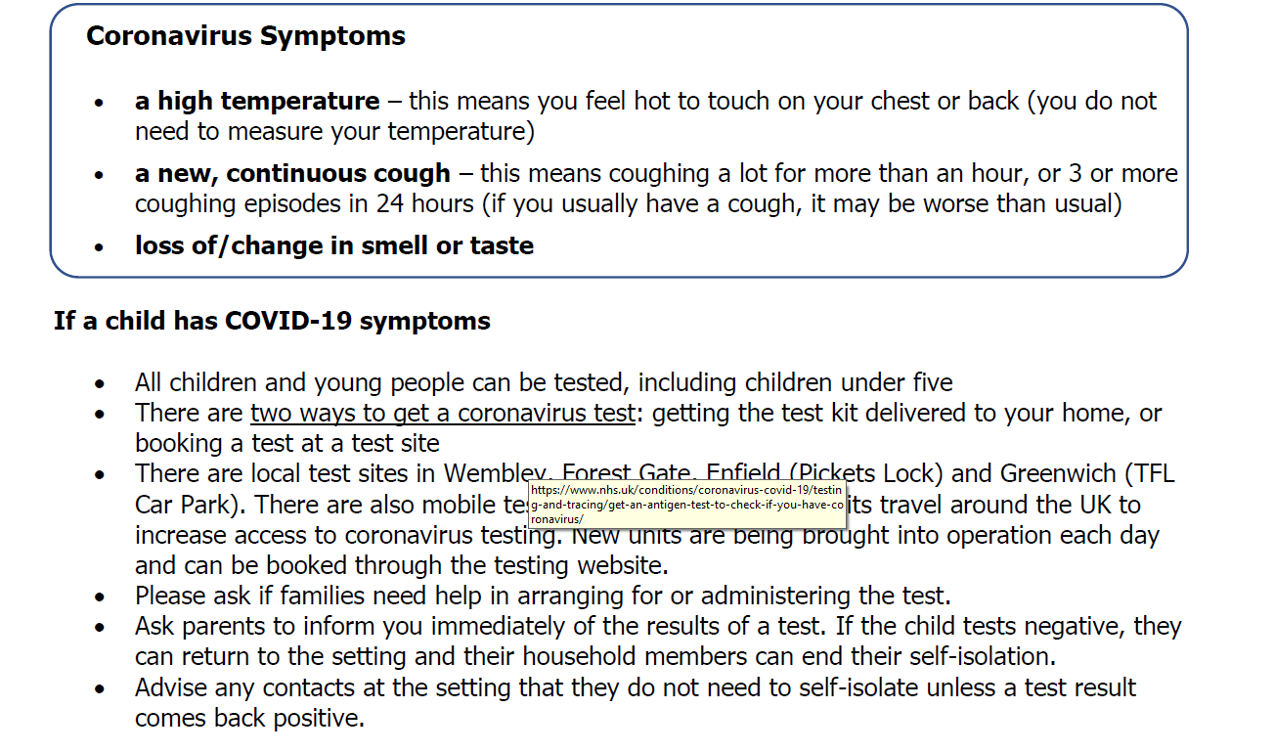

Positive Covid-19 cases
If you have a confirmed positive case of Covid-19 in your setting you must inform:​
- Islington FIS: fis@islington.gov.uk
- Ofsted [Ofsted notification form]
- Social worker involved with affected child/ren
There are certain specific conditions or cases where settings should be escalating to the London Coronavirus Response Cell (LCRC): 033 303 0450. Full guidance is in the pack; in summary you must contact LCRC if:
- There have been any hospitalisations
- For larger nursery settings: if 10% or more of a bubble is affected within 14 days; 10% of staff are affected within 14 days; 3 or more bubbles are affected
Early years providers are being asked to conduct their own on-site risk assessment when they receive notice of a positive Covid-19 case which affects their provision. The London Coronavirus Response Cell (LCRC) has created a pack to support settings. Summary information is available for nurseries and childminders. Settings can get further advice from:
- DfE: 0800 046 8687
- Islington Public Health: CIPHadmin@islington.gov.uk

