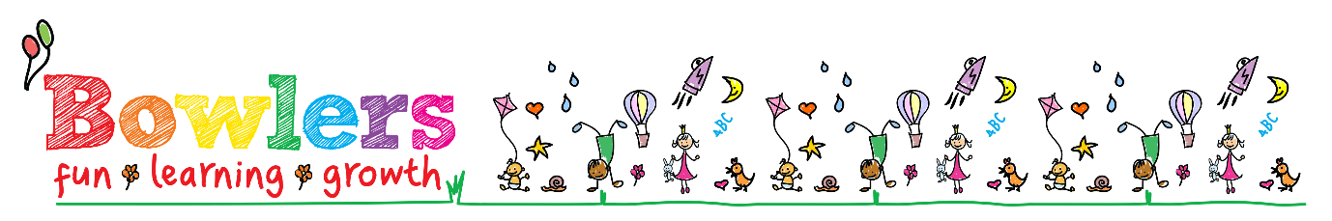

HEALTH, ILLNESS & EMERGENCY POLICY

It is our policy to encourage and promote good health and hygiene for all the children in our care. This specifically includes monitoring the children for signs and symptoms of communicable illnesses such as Chickenpox, Measles, Mumps, Meningitis and Vomiting & Diarrhoea and so forth.

The welfare of a sick child will be our priority until the Parent/Carer arrives to resume responsibility; We do have a duty to the remaining children and staff to safeguard them from contracting the illness from the sick child. With this in mind, the nursery reserves the right to contact the Parent/Carers to request that they collect their child as soon as possible.

Parents will be contacted if the nursery has ascertained that their child has a Temperature/Fever. First Aid practices will be put into place to bring down the temperature – however if this does not happen and the child remains poorly the Parent/Carer will be contacted to collect the child immediately.

The nursery can only administer prescribed medicines to the children (or medication which can deter the onset of a severe condition, see Medication Policy); It is imperative that the Key Person is made aware if their Key child has any signs of an illness or has been given Calpol or Nurofen prior to attending nursery.

In the case of a serious accident or illness, the Parent/Carer will be contacted immediately along with Medical Professionals. In the unlikely event that the Parent/Carer cannot be contacted then the nursery will assume Parental Responsibility and seek and permit appropriate medical attention. (See Parental Consent for Emergency Treatment)

MEDICATION POLICY

At Bowlers Nursery we recognise that children will become ill over the course of time that they are at the nursery. We endeavour to create a clean and healthy environment but recognise that children will be ill despite all our efforts.
At Bowlers Nursery we recognise that ill health can impact on the children’s health and development and as such we want to support the children and their families during these times.
At Bowlers we want to maintain an inclusive practice and as such we do not want families to feel excluded due to health issues; we are committed to supporting families as much as possible and we have many policies in place that enable children with medical, health or dietary needs to attend nursery.
Assuming that a child has not got a communicable illness such as Chickenpox, Measles, Sickness & Diarrhoea, Hand Foot and Mouth, Congungivitis and so forth they will be able to attend nursery. However, if they do have a communicable illness they will not be able to attend nursery until they have fully recovered. In the case of Congungivitis, once the child has started treatment they will be able to return after 24hrs.

In order to allow a child to attend nursery whilst recovering from an illness or coping with an on-going medical condition the nursery is permitted to administer prescribed medication such as antibiotics. The child will be able to attend nursery 48 hours after their initial dose; this will allow the medication to enter the child’s system and start them on their road to recovery, it will also present symptoms if the child has an adverse reaction to the medication.
Parents are asked to use their judgement in regards to whether their child is well enough to cope with the nursery day even after the first 48 hours. The Child’s Key Person will monitor their progress and keep parents informed. Parents may still be asked to collect their child if the child is not well enough during the day.

It is also a requirement that your child is sent home with a temperature of 37.8 degrees or above. Children with a temperature of 37.8 or above are also unable to return until 24hrs after they were sent home from Nursery.

There are some cases in which the nursery is permitted to administer medication which is not prescribed. The Staff at Bowlers recognise that young babies and children under one year can be prone to extremely high temperatures. To ensure that children do not go into a febrile convulsion the staff will administer Calpol or Neurofen. Parents will be contacted for verbal consent and will still be required to collect their child.

At the nursery we acknowledge that some children have an on-going medical condition such as allergies which if severe enough can lead to Anaphylaxis; in this instance the staff are permitted to use a number of deterrents such as Antihistamine medication which will alleviate the allergy. Failing that an Epi-pen (Adrenalin Medication) may have to be administered. Some of the staff have been trained in administering an Epi-pen.

Staff can also administer creams/lotions/teething gels which can ease discomfort for skin conditions and teething pains respectively.

Medication Procedure

Staff must be aware of the storage and use of medicines outlined below:

- All medication must be clearly dated and labelled and stored securely according to instructed guidelines
- Parents must complete and sign consent forms
- The Key Person & Manager/Deputy must sign the form if medication is administered
- The administration of medication must be accurately recorded i.e. child’s name, medication, date, dosage, time etc.
- Staff to receive appropriate training for the administration of Inhalers or Epi-pens etc.

The Key Person will be responsible for monitoring symptoms of an illness/ respiratory difficulties or an allergic reaction – in an event that medication needs to be administered, consent forms must be observed for correct dosage and parents must be informed prior to and proceeding the medication.

All information pertaining to administering of medication must be stored securely for a minimum of 21 years.

