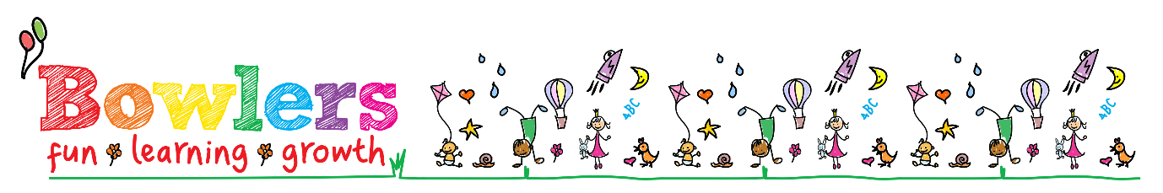

Date agreed  November 2019 | Review Cycle  Annual 2 years | Due for review  November 2021
Signed

Preventing extremism and radicalisation policy

At Bowlers Nursery we recognise that it is very rare for nursery age children to become involved in extremist activity to the point of committing criminal acts. We know young children can however be exposed to extremist influences or prejudices and views that differ from the majority of society, including via the internet and social media used by parents and carers, from an early age.

Working with other local partners, families, communities, we can help support children who may be vulnerable as part of our wider safeguarding responsibilities. It is our most fundamental responsibility to keep our children safe and prepare them for life in modern Britain, and to be a responsible global citizen.

We promote the British Values: the values of democracy, the rule of law, individual liberty and mutual respect and tolerance for those with different faiths and beliefs; we encourage children to respect other people as well as the world around them.

Our goal is to build mutual respect and understanding and use of dialogue not violence or aggression as a form of conflict resolution using a curriculum that includes:
- Citizenship programmes
- Learning to value each other
- Celebrating every aspect of diversity

Extremists of all persuasions aim to develop destructive relationships between communities by promoting division, fear and mistrust of others based on ignorance or prejudice. Education is a powerful weapon against this, equipping young people with the knowledge, skills and critical thinking to challenge and to debate; and giving young people the opportunity to learn about different cultures and faiths.

As part of wider safeguarding responsibilities, school staff will be alert to:

- Parental reports of changes in behaviour, friendship or actions and requests for assistance relating to either the child or other family members.
- Changes in behaviour of parents and carers linked to the centre that is vastly different to how they had previously presented
- Partner schools, local authority services and police reports of issues affecting pupils in other schools.
- Children voicing opinions drawn from extremist ideologies and narratives
- Use of extremist or ‘hate’ terms to exclude others or incite violence
- Young children talking about what they have seen, heard or watched at home
- Young children talking about what older siblings are doing

What to do if you have concerns:

If you feel a child is at risk from extremism or radicalisation within the family or community please notify the designated safeguarding lead and complete a ‘safeguarding child protection reporting form’

As with any safeguarding concerns, follow the policy.

This policy must be read in conjunction with the following:-
- ‘Safeguarding children in Education Policy for Bowlers Nursery
- British Values Policy

